MACHINE LEARNING

GITHUB LINK: [https://github.com/sparsha21/sparsha21](https://github.com/sparsha21/sparsha21%20)

RECORDING VIDEO LINK: <https://drive.google.com/file/d/1AY0MuU81iMx-KVZlYWcY12k5K4VZNTYs/view?usp=sharing>

NAME:SPARSHA REDDY ADURI

700764939

Q1. Displayed a star pattern using for loop.

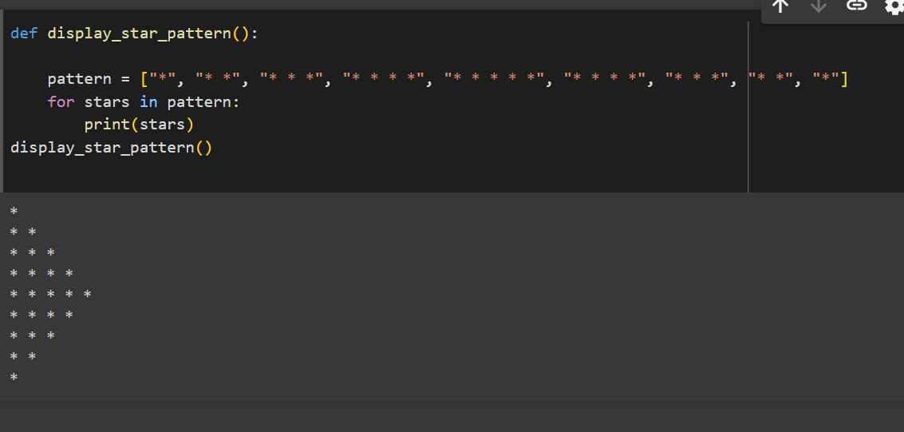

Q2. With the following list by using for loop as i=0 we got odd indexes as a result.

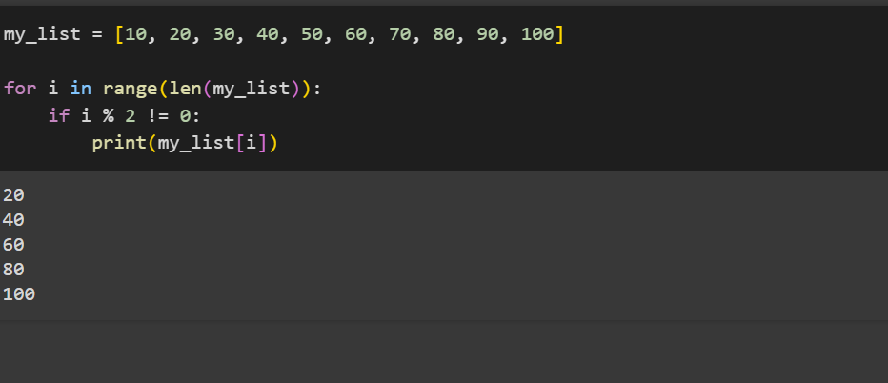

Q3. By using the input we have used append function to get the type of elements in the list.

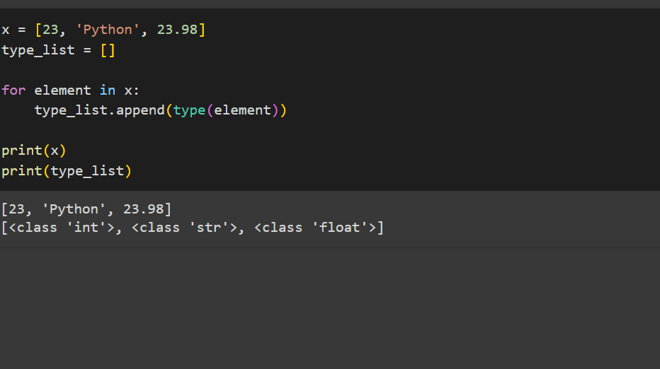

Q4. By this function uses a set to remove duplicates from the list.

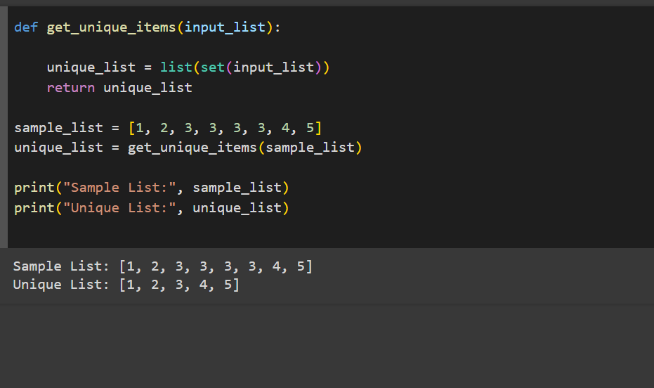

Q5. By using the input string it takes the input and counts the number of upper case and lower case letters.

